**TASK-06**

Bank Charges

**EXPLANATION:**

The program asks the user to enter his / her checks written to the bank, the program the calculates the money that the client has been charged by the bank. If the balance of the client becomes less than 1500, the program automatically adds the amount of Rs 100 as an extra charge. If the user accidently enters amount of check or anything else less than 0, the program gives an error and again asks the user for the details. If the user enter a character, the program again gives the error.

**INPUT:**

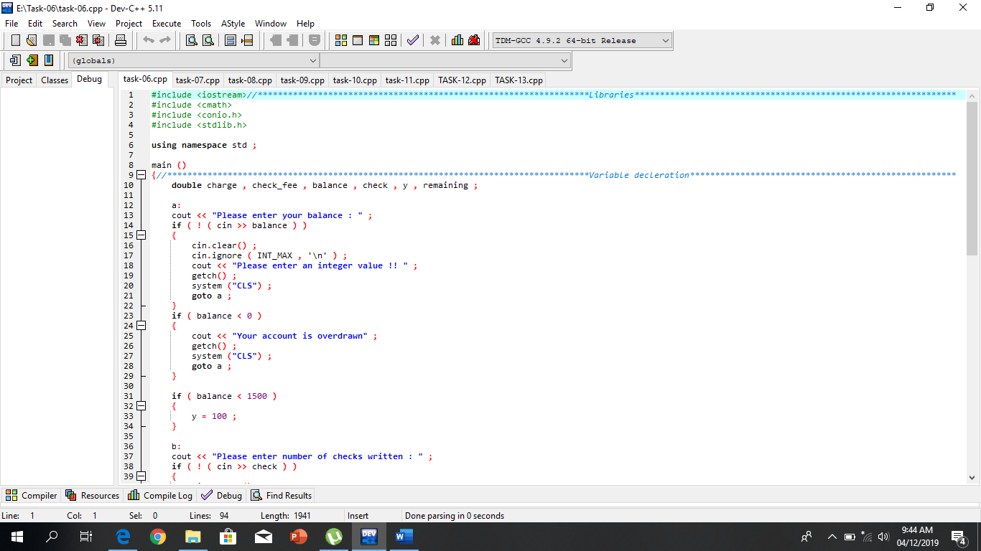

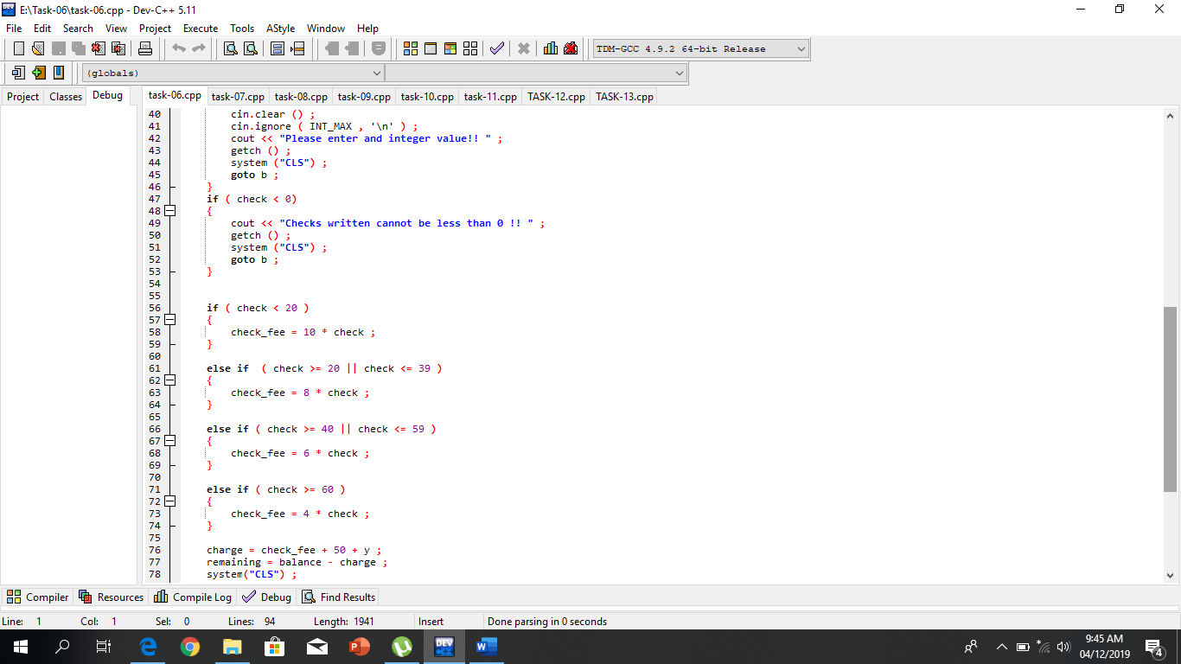

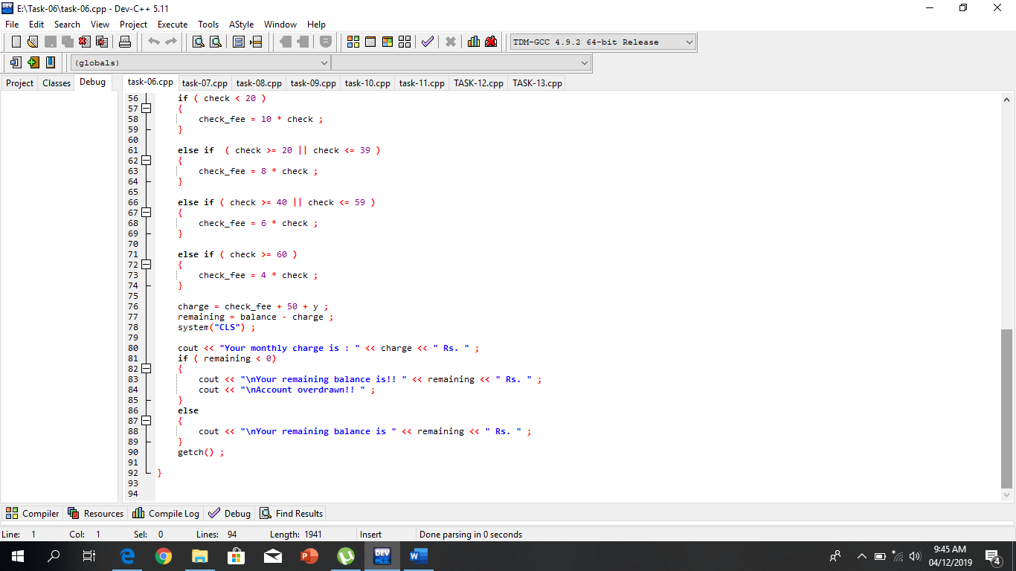

**OUTPUT:**

